Call for Speakers
2023 NW Conference on Childhood Grief
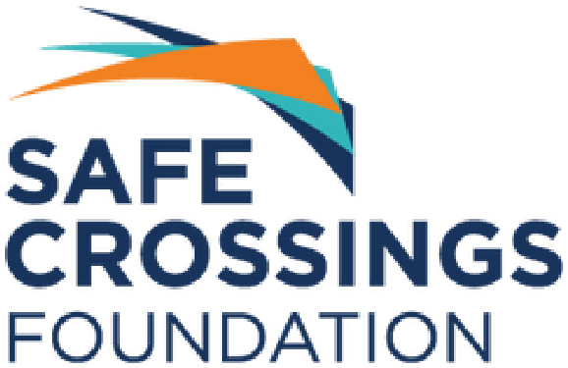
In response to a call from local providers of children’s grief support, Safe Crossings Foundation (SCF) will be presenting the 9th Annual Northwest Conference on Childhood Grief. As the leader in funding grief support services for children in the Pacific Northwest, SCF is hosting a conference that provides continuing professional development credits while building community, sharing ideas and learning together.

This multi-day conference will be held virtually on February 27th-28th 2023 and will focus on the theme of Connecting Children to Support. The conference is designed for support providers such as clinicians, therapists and counselors, therapists-in-training, teachers, school staff, and healthcare workers.

Symposium and Workshop-Style Session Presentations
SCF invites you to lend your expertise by participating as a full symposium or workshop session presenter.
To offer CEU credits to attendees, symposium speakers must have obtained a Master’s degree or higher. Some workshop sessions may be offered by speakers without a Master’s degree.
Panels and interactive workshops are welcome – we love creativity and hands on experiences! Sessions are an hour to an hour and a half in length, so please note your preferred session length.
Presentation applications are due Friday, November 18, 2022. Materials for selected presentation will be due December 16, 2022. Note: The conference registration fee will be waived for presenters.

Goals for Conference
- Provide education on best practices through the exchange of timely clinical information, programs, advances in research, and successful ideas for children’s grief support programming
- Provide practical tools and skills to use when supporting grieving children
- Create a space for sharing, connecting, and learning from each other and diverse perspectives
- Promote networking and support among colleagues

Requested Topics
Type of Death  - Suicide  - Addiction  - Prolonged illness  - Anticipatory grief  - Sudden/other traumatic death  Building Community  - Culturally relevant programming  - Accessibility of services  - Services in community locations | Self-Care  - Organizational self-care  - Tools for adults/children  - How grief manifests in the body  Research and Data  - Historically marginalized populations (race, ethnicity, sexual orientation, immigrant communities, etc.)  - Programs in multiple languages | Practices for Support  - Art and play therapy  - Support when time is limited: small ways to be mindful of youth and provide support  - Support for grieving guardians  - How schools can best provide support after a student has experienced a death

Presenter Application
Applications are due Friday, November 18, 2022, by email to info@safecrossingsfoundation.org.
Contact Karen Schrantz with questions at 206-650-9368.
In submitting this application, you acknowledge the following: 1) agreement to meet all deadlines for materials; 2) presenters are responsible for all travel, lodging and other related expenses; 3) there is no compensation for presenting at the Conference; 3) if your presentation is selected, the information provided in this application, including your biographical information will be used in conference materials.
Name
Click or tap here to enter text.

Address
Click or tap here to enter text.
City | State | Zip
Click or tap here to enter text. | Click or tap here to enter text. | Click or tap here to enter text.

Phone | Email
Click or tap here to enter text. | Click or tap here to enter text.
Organization | Title
Click or tap here to enter text. | Click or tap here to enter text.
Accreditations
Click or tap here to enter text.

- Brief Biography; if a panel, include all presenters (to be included in materials):
Click or tap here to enter text.
- Presentation Title:
Click or tap here to enter text.
- Brief Description of Presentation (to be included in materials):
Click or tap here to enter text.
- Three Learning Objectives (required for CEU credits):
Click or tap here to enter text.
- Three to Five (3-5) Literature References (required for CEU credits, must be published within the last 10 years):
Click or tap here to enter text.
- Identify Audiovisual needs:
☐ Screen Sharing via Zoom ☐ Other: Click or tap here to enter text.

- Professional References (regarding speaking and teaching ability):
Click or tap here to enter text.
- Please describe your: 1) professional expertise & qualifications, 2) speaking experience, and 3) list of published work
Click or tap here to enter text.
- Please provide your resume.

